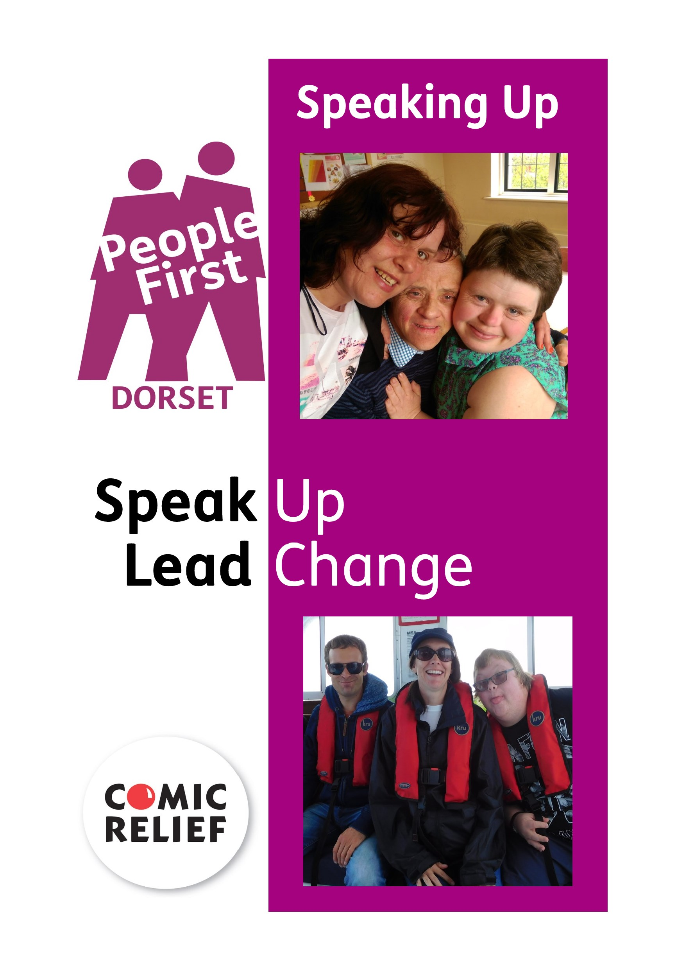
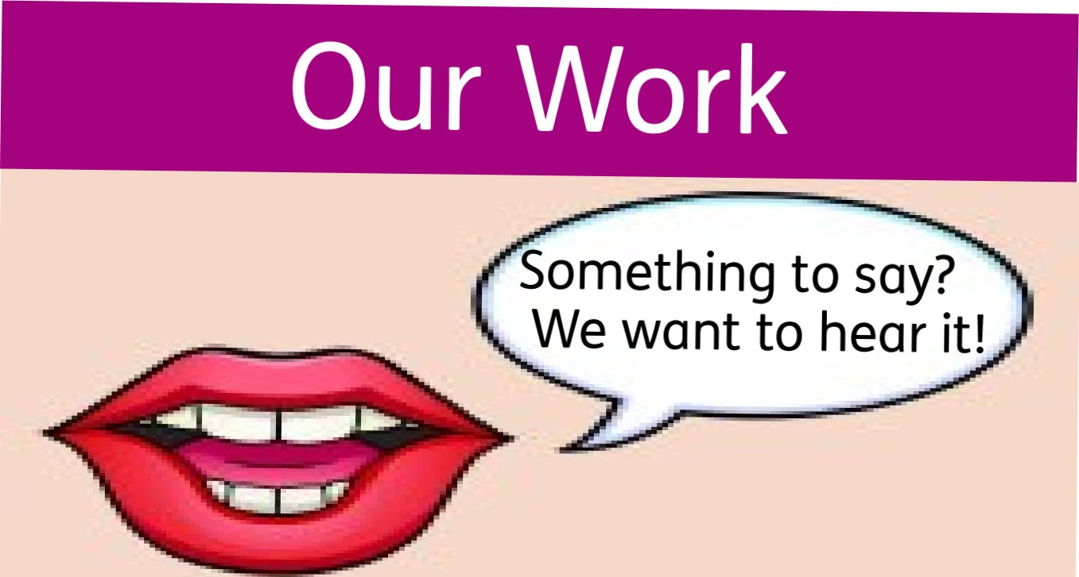
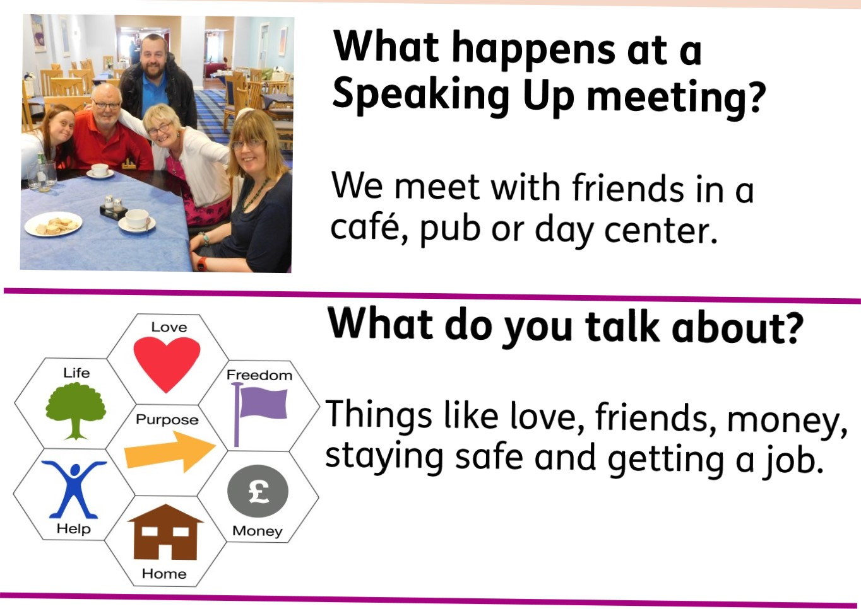
When do you meet?
We meet once a month at a venue that you choose!
Meetings last about 1 hour.
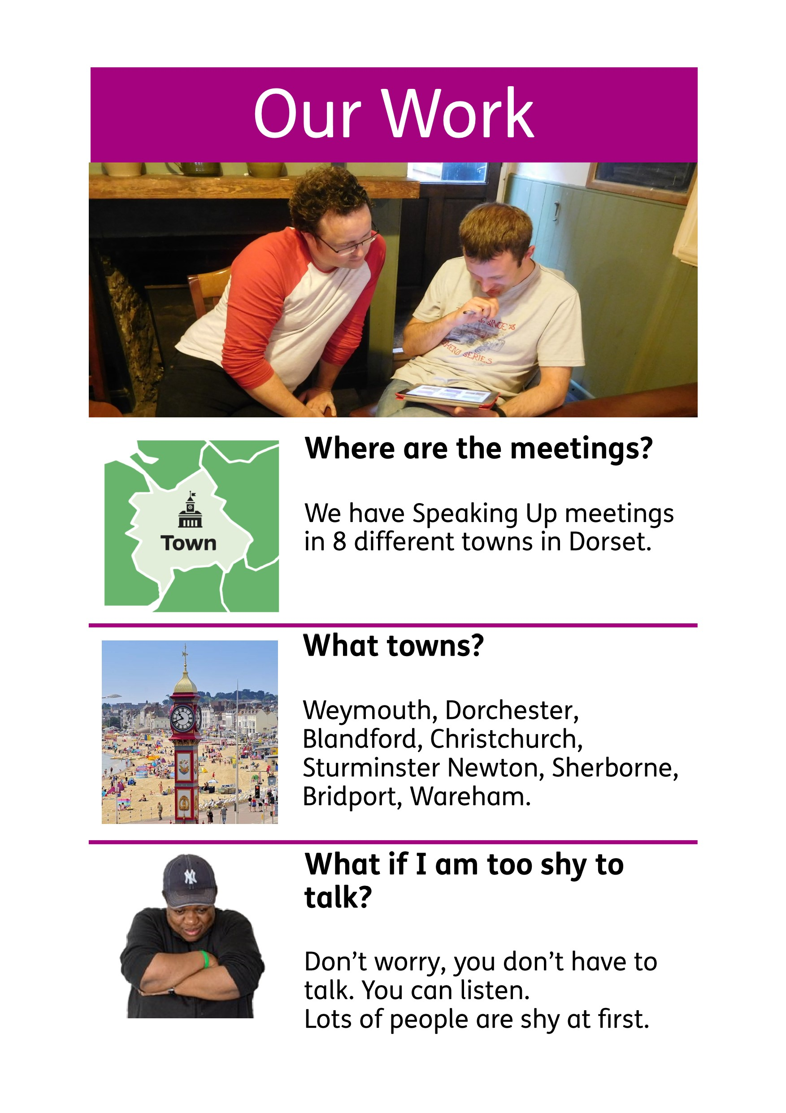
Lots
of
people
are
shy
at
first.
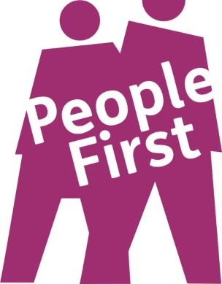
People First Dorset is the name of the Charity that runs the Speaking Up project.
O
Lisa and Chris work on the
DORSET
Speaking Up project.

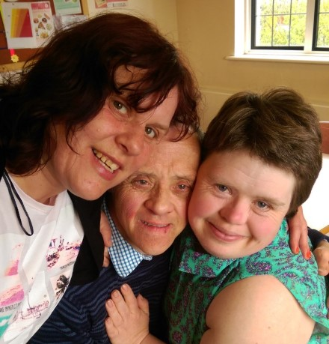
The Speaking Up meetings are run by people with learning disabilities.
Lisa and Chris help people with this.

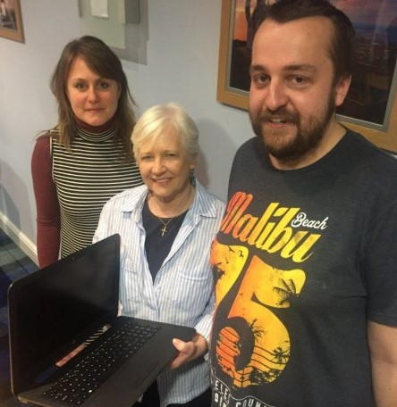
This is a photo of Lisa, Kate and Chris.
Kate used to be the Mayor of Weymouth.
Kate is giving us a laptop so we can help members to use the internet.

The Team
Its important for people with a learning disability to speak up.
I feel more positive and 1 ¹ m confident at speaking up.
I like listening to what other people have to say.

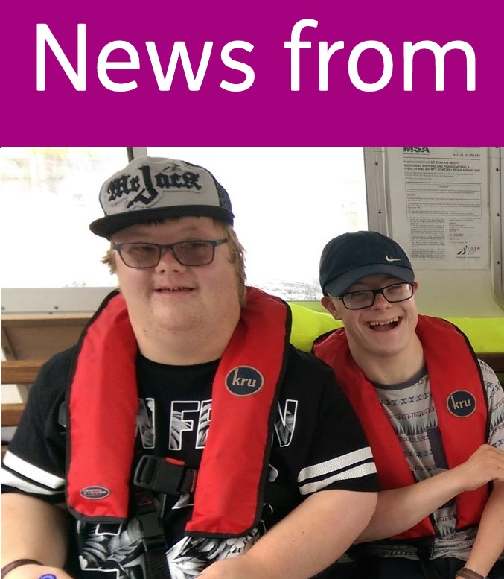  Dorchester | our groups!  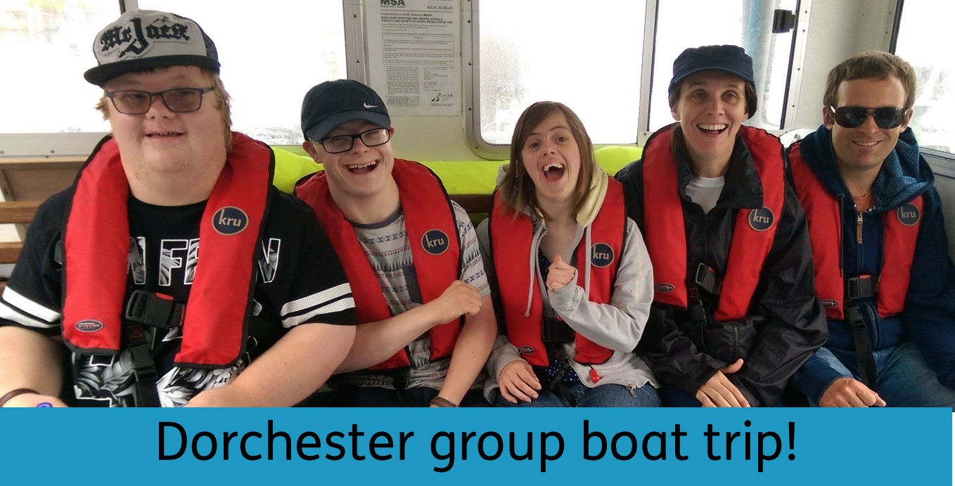
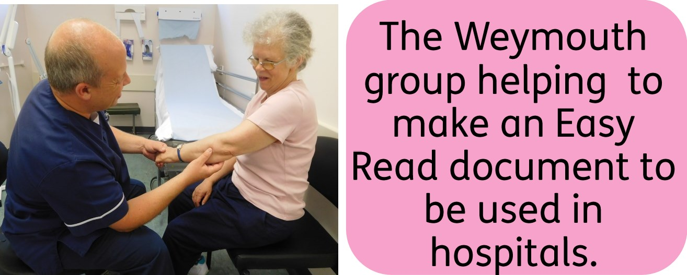
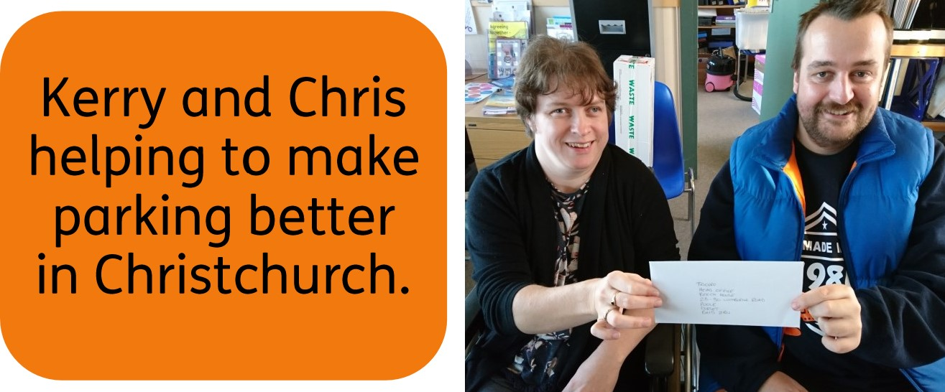
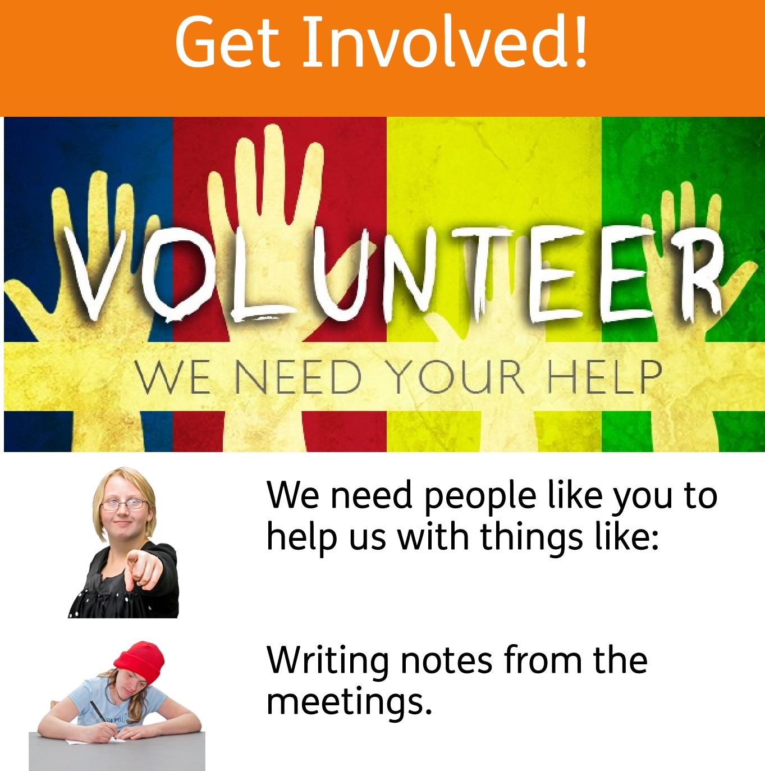
NewMess
up
• to
Sending emails and using social media.
Taking photos and videos.
Giving support and sharing your experiences.
